Integrate AI Builder
Scenario
In this lab, you will be using the AI Builder to process the construction funding request form document that was emailed to the funding shared mailbox to extract essential information. The extracted information will be stored in Dataverse for use in the funding process.
High-level lab steps
- Use sample request forms to train an AI Builder model
- Modify the cloud flow to use the model to process the inbound document
- Store the extracted information in the Loan Draw table
Exercise 1: Train model for request form
In this exercise, you will create an AI Builder model that will process the funding request form.
Task 1: Create AI Builder model
- Go to the lab resources folder and open the Train folder.
- Click to open Jim Glynn.pdf.
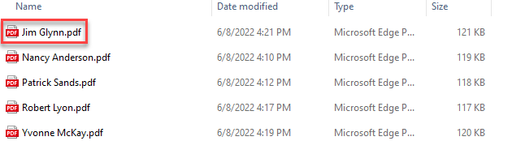
- The documents from which the model will extract the data will look like this document. Keep this file open, you will need it during model creation.
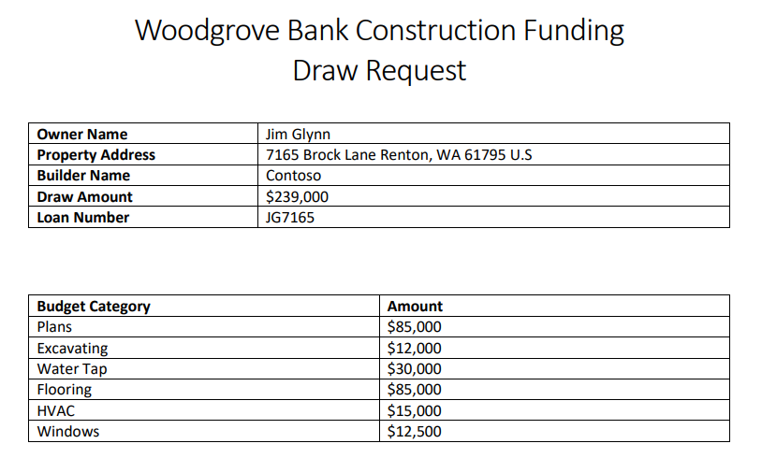
- Navigate to https://make.powerapps.com/ and make sure you are in the Dev environment.
- Click … More and select Discover all.
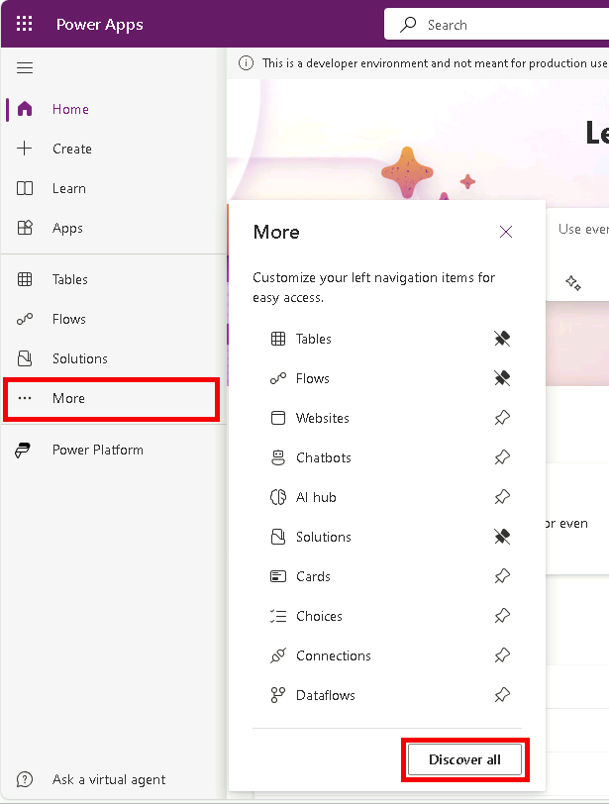
- Under AI select AI models.
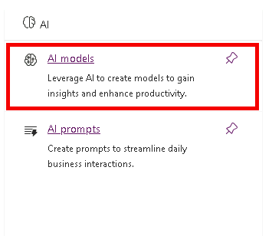
- Select Extract custom information from documents.
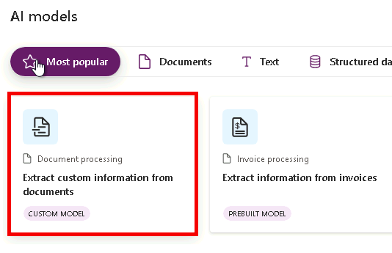
- Click Create custom model.
- Select Fixed template documents and click Next.
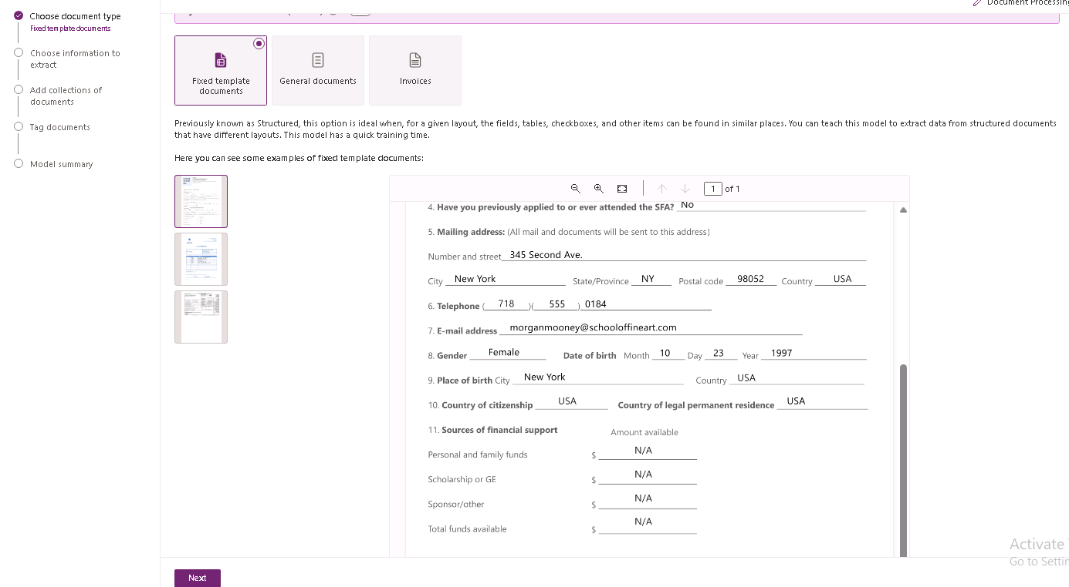
- Do not navigate away from this page.
- Go to the Jim Glynn pdf fie, you will create fields and a table in the model that match the fields and the table in this document.
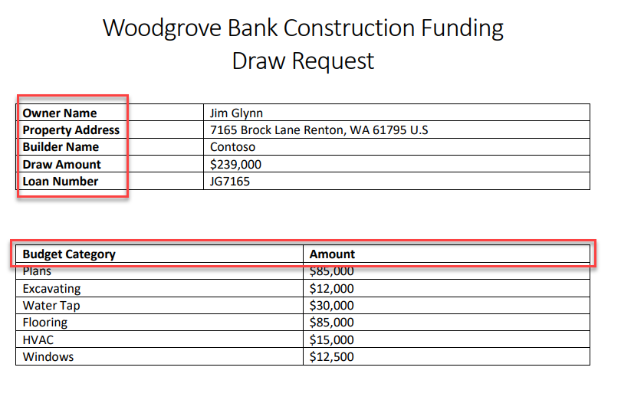
- Go back to the model. Click the chevron button on the + Add button and select Text field.
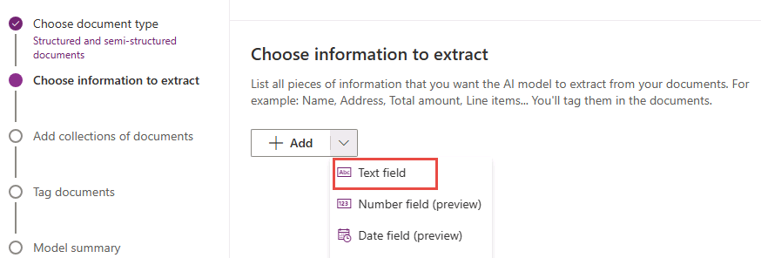
- Enter Owner Name and click Done.
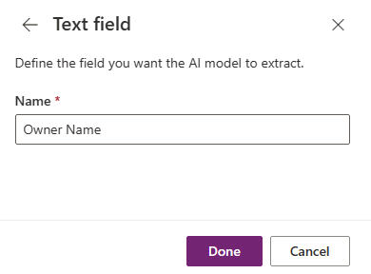
- Select the + Add button and select Text field again.
- Enter Property Address and click Done.
- Select the + Add button and select Text field.
- Enter Builder Name and click Done.
- Select the + Add button and select Text field.
- Enter Draw Amount and click Done.
- Select the + Add button and select Text field one more time.
- Enter Loan Number and click Done.
- You should now have five text fields added.
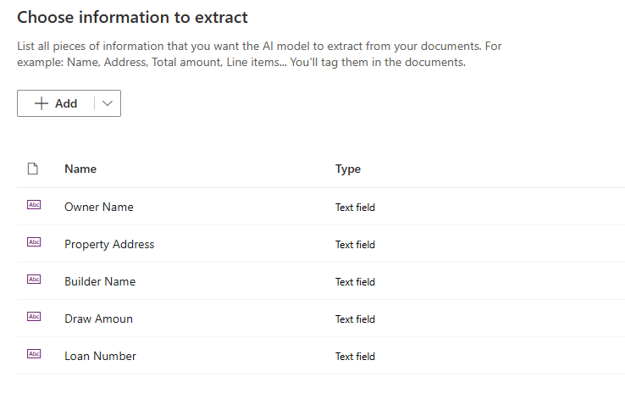
- You will now add the table details. Click the chevron button on the + Add button and select Table.
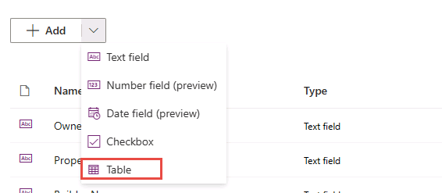
- Enter Budget Items for Table name.
- Click on Column 1 and select Edit column.
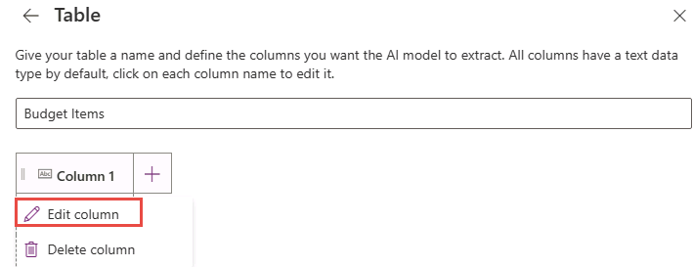
- Enter Budget Category and click Comfirm.
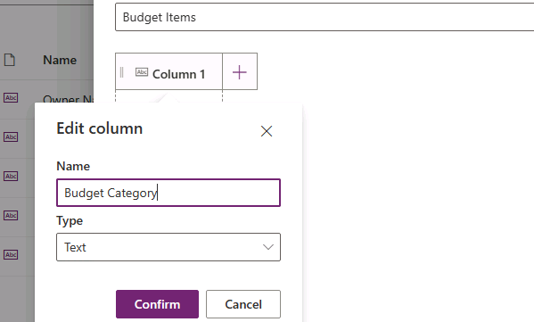
- Click + New column.
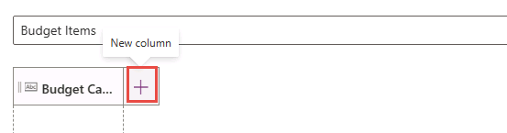
- Enter Amount for Name and click Add.
- Your table should now have 2 columns. Click Done.
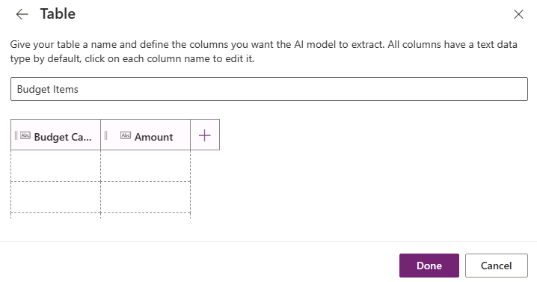
- Click Next.
- Do not navigate away from this page.
Task 2: Add sample documents
- Click New collection.
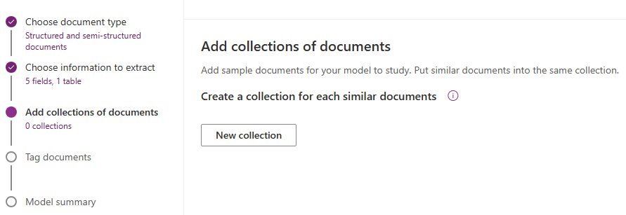
- Enter Sample documents for collection name and click + add.
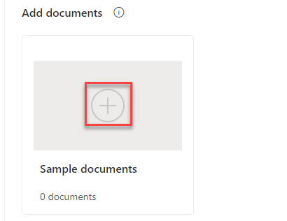
- Click Add documents.
- Select My device.
- Select all 5 PDF files located in the Train folder and click Open.
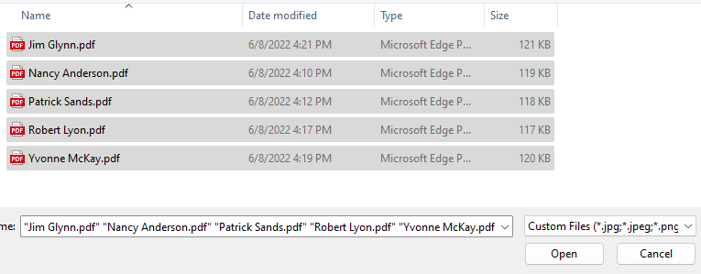
- Click Upload 5 documents and wait for the files to be loaded.
- Click Done.
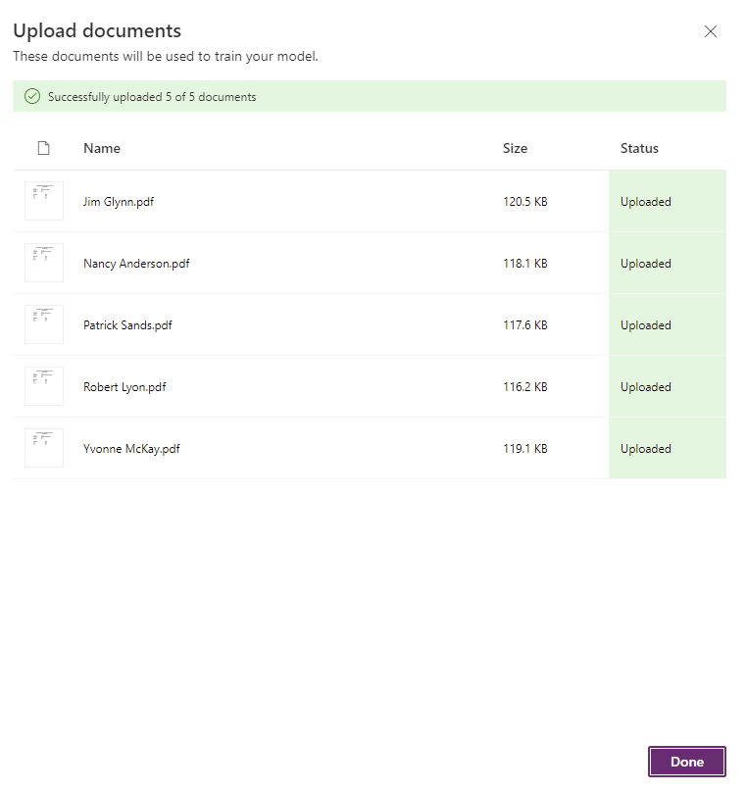
- Click Next.
- Do not navigate away from this page.
Task 3: Tag documents**
- Click on the name of the owner and select Owner Name as text field.
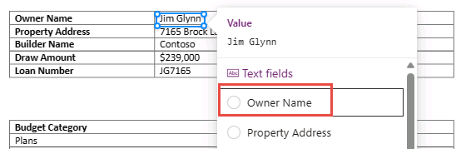
- Select on the address and select Property Address as text field.
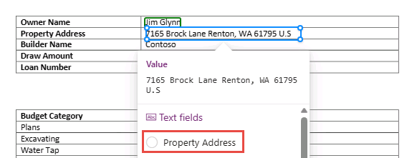
- Select on the builder name and select Builder Name as text field.
- Select on the draw amount and select Draw Amount as text field.
- Select on the loan number and select Loan Number as text field.
- All your fields should now be tagged.
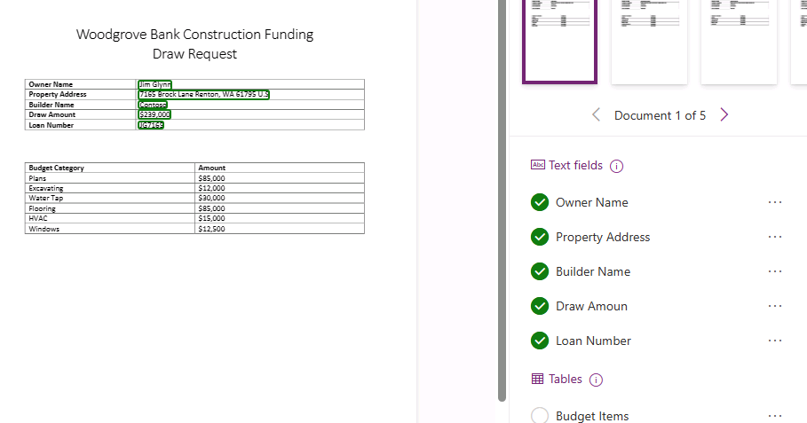
- Select table area of the document and select Budget Items table.
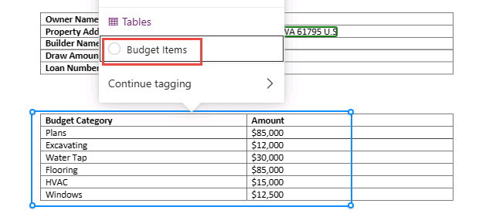
- Turn on Advanced tagging mode.
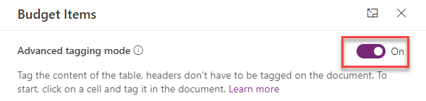
- Click to and select the first cell.
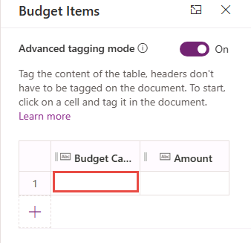
- Go to the document and select the first budget category item name.
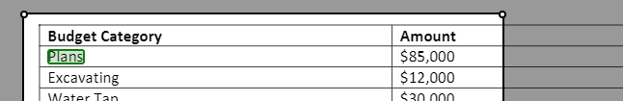
- The selection should automatically advance to the second cell. Select first budget category item amount.
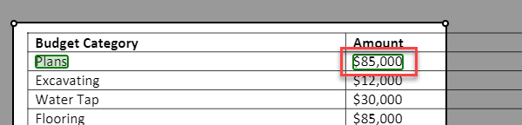
- The selection should automatically advance to the first cell of the second row. Select the second budget category item name.
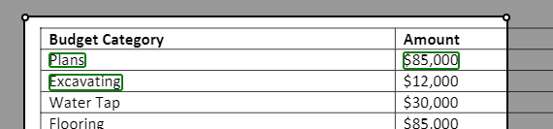
- Continue until all the items in the table are tagged.
- The table should now look like the image below. Click Done.
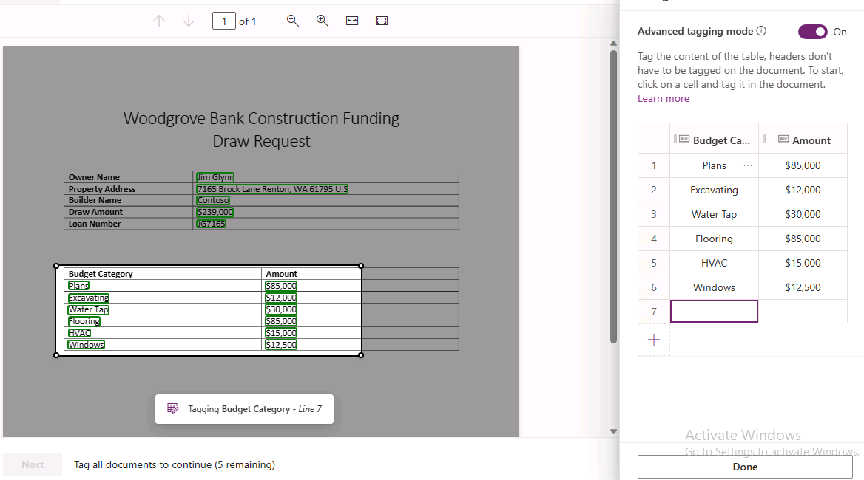
- Select the second document.
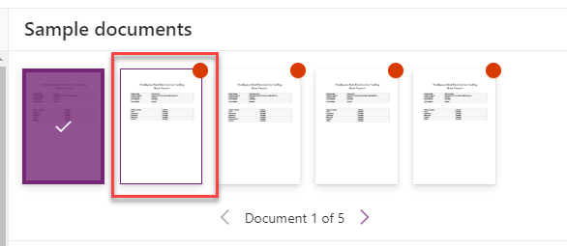
- Tag the fields and for the second document.
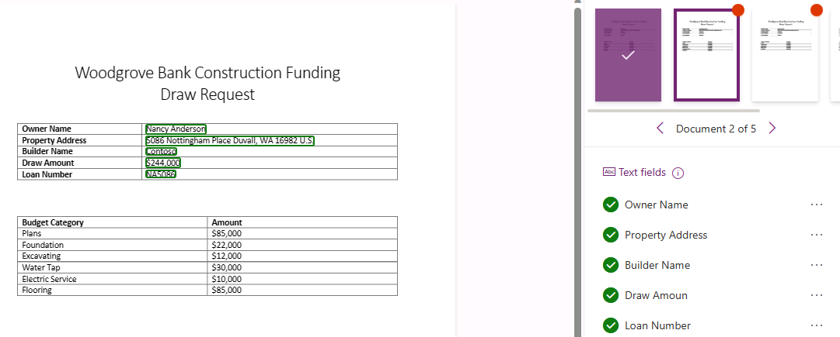
- Select table area of the document and select Budget Items table.
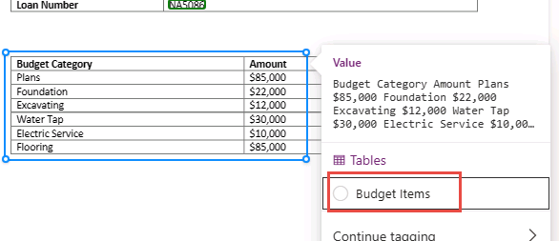
- Make sure Advanced tagging mode is turned on.
- Tag all the items in the table.
- You should now have two documents tagged.
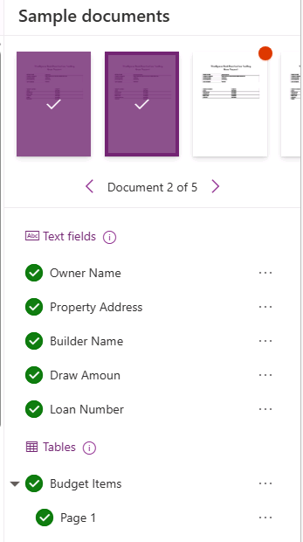
- Tag the rest of the documents.
- Click Next. You won’t be able to advance to the next step until you have finished tagging all the documents.
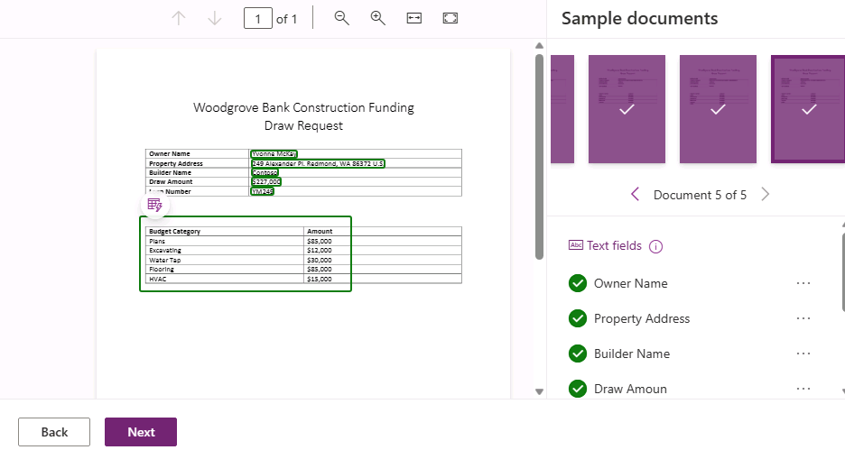
- Click Train and wait for the training to complete.
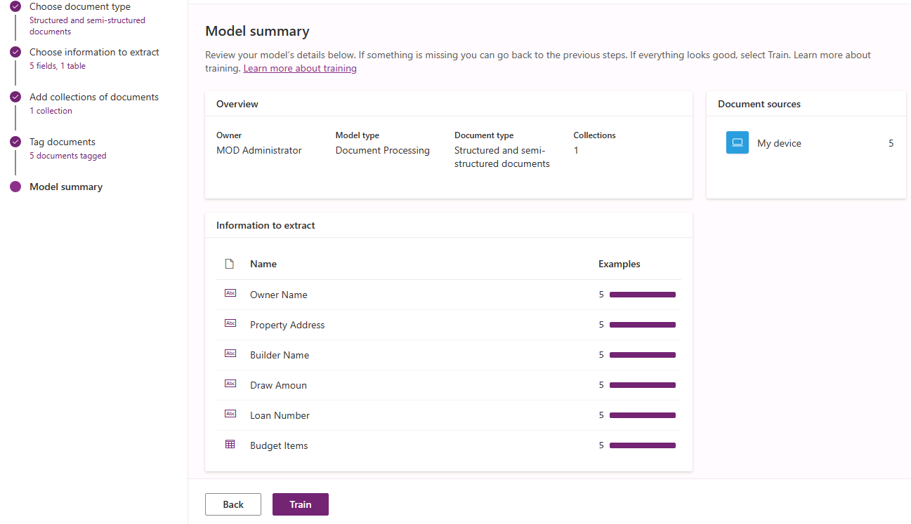
- Do not navigate away from this page.
Task 4: Test and publish the model
- The model should automatically open after the training completes or click Go to models.
- Click Quick test.
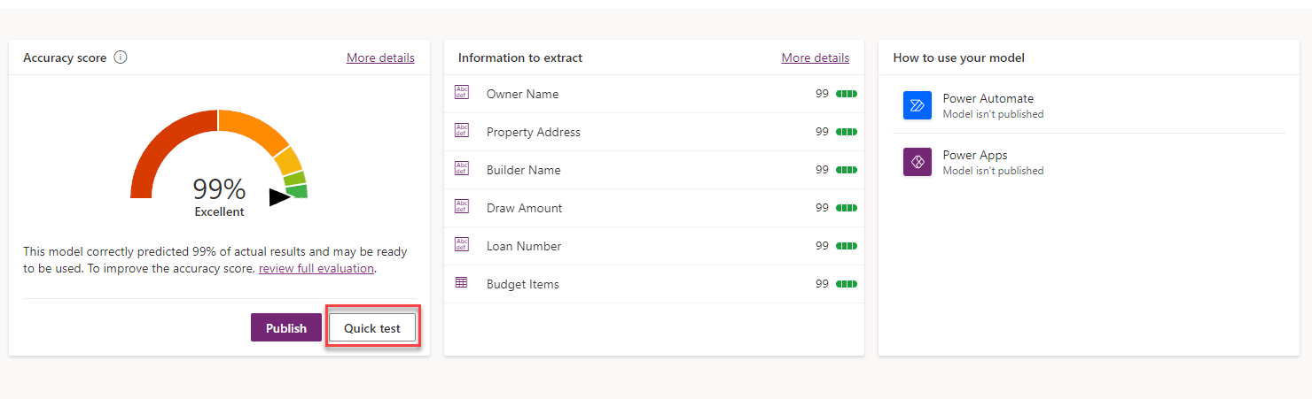
- Go to the lab resources folder and open the Test folder.
- Drag the Maria Campbell.pdf file to the model quick test pane.
- The model should run and complete the document analysis.
- Click on the table area.
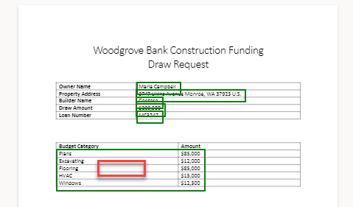
- You should see the budget items from the test file.
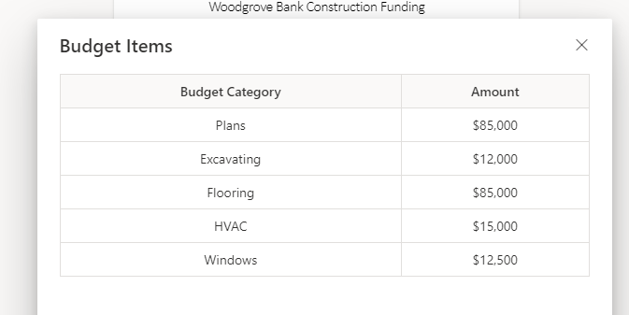
- Evaluate all the values the model extracted and make sure it matches the test document.
- Click Close.
- Click Publish and wait for the publishing to complete.
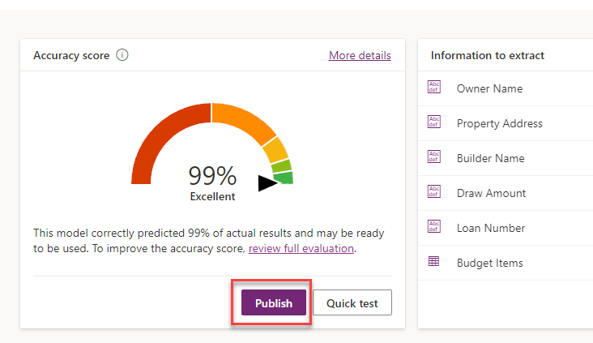
- Your model should now be ready for use.
Exercise 2: Create a flow to use AI Builder model
Task 1: Use AI Builder
- Navigate to https://make.powerapps.com/ and make sure you are in the Dev environment.
- Select Solutions Supply Chain Order
- open the Supply Chain Order solution.
- Click Add Existing | AI Model.
- Select your Document Processing model and click Add.
- Select Cloud flows, Click New and create new Instant flow.
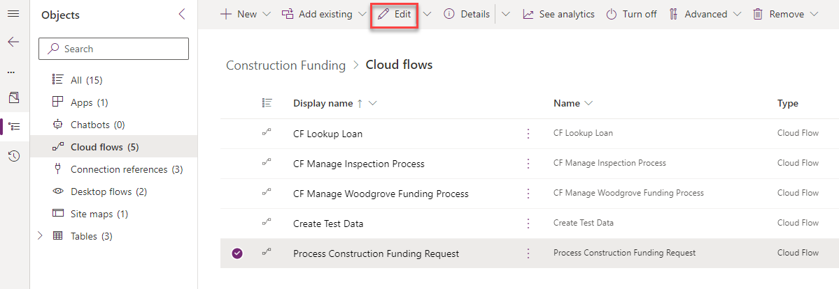
Steps in flow Manually trigger , Add file type as input
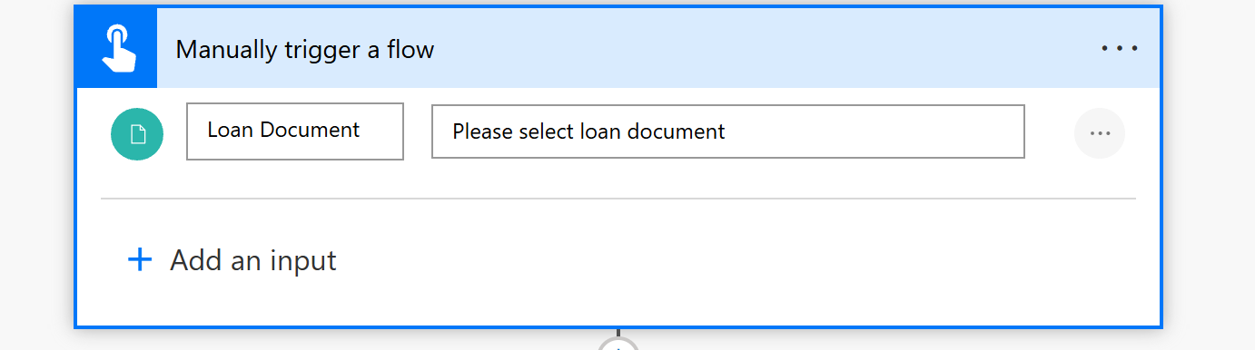
Add the Process model
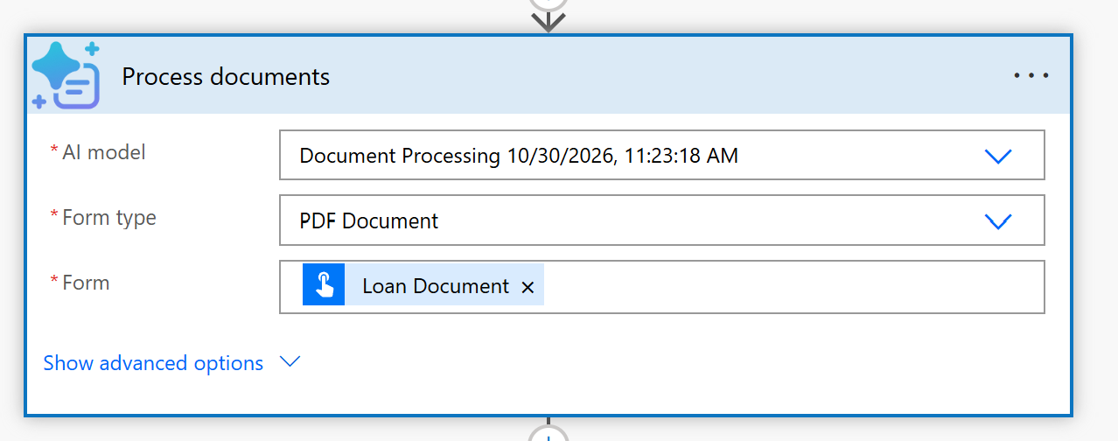
Initialize a variable
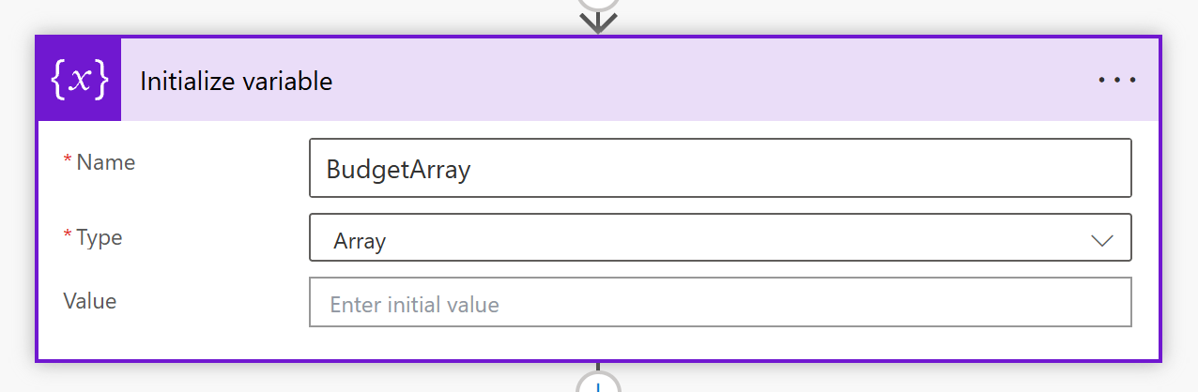
Make the Budget entries as Array format
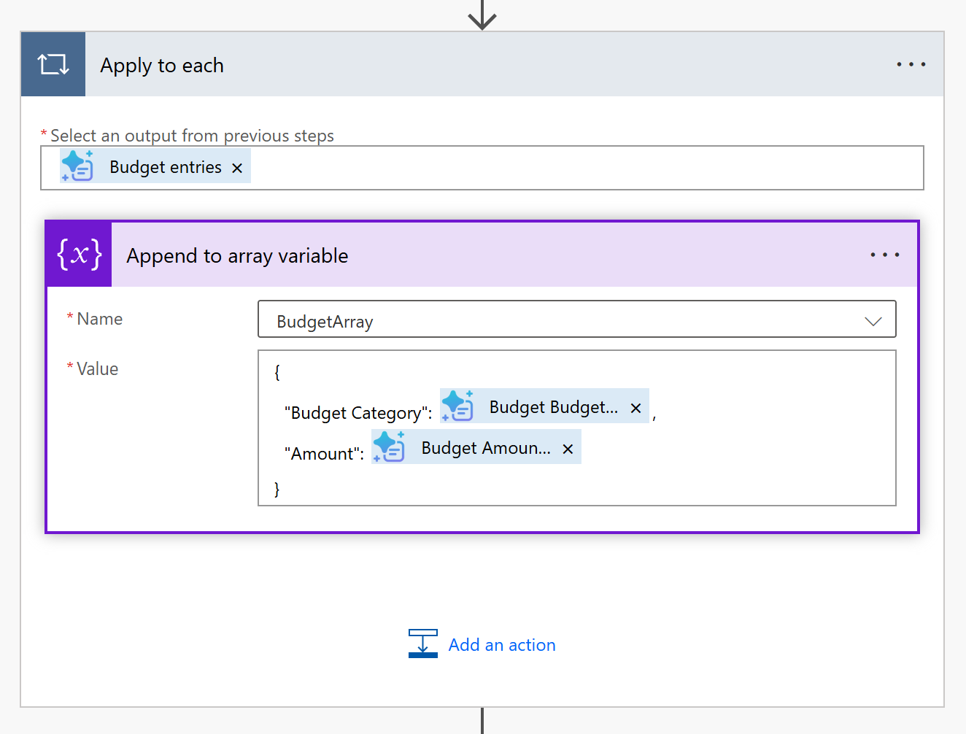

Then change array to HTML

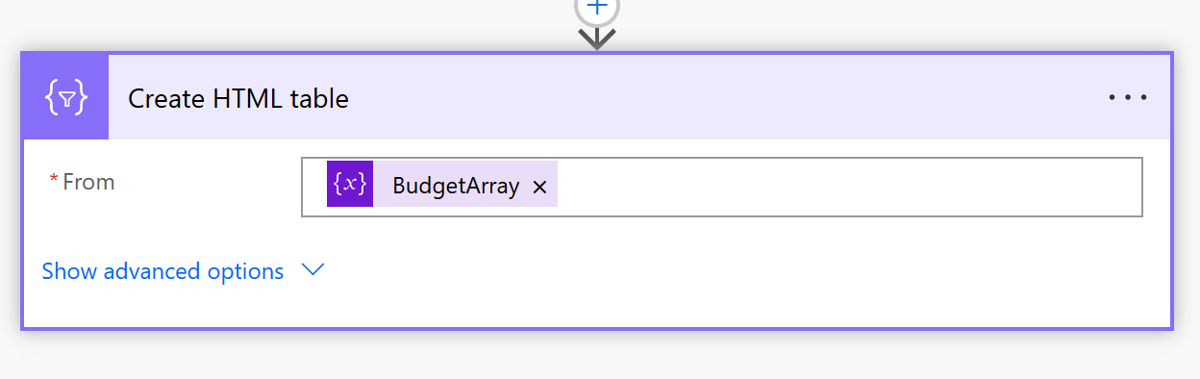

Final flow output
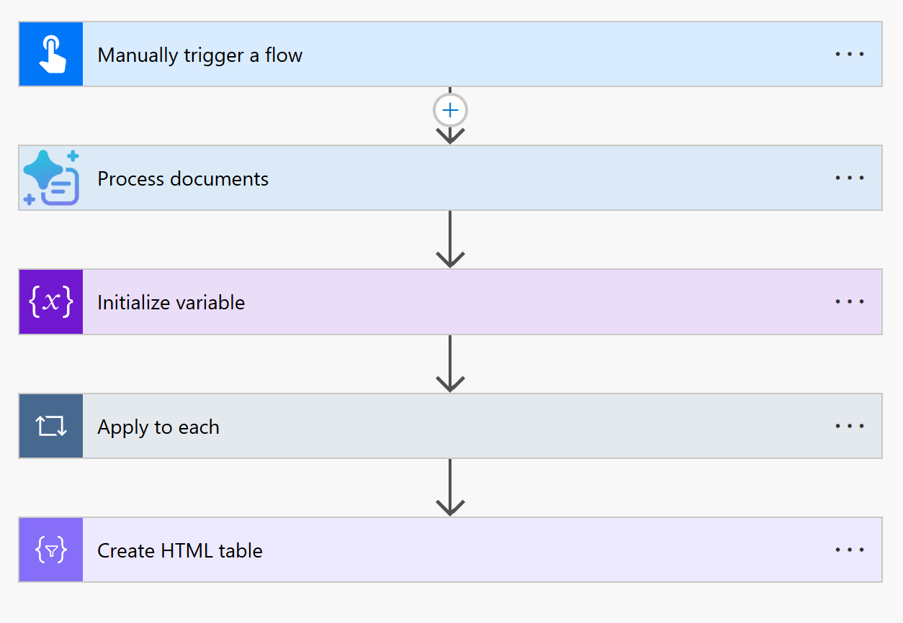
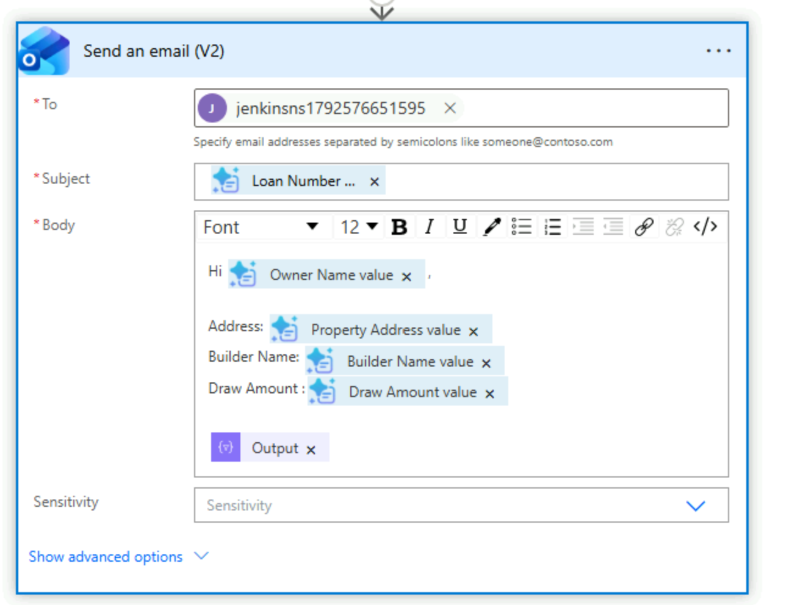
Testing output
